Robot Framework – ALM Integration

Table of Contents
1 Integration with ALM 3
2 Using a 32bit COM object in a 64bit environment 3
3 Change history 5

Integration with ALM

- Open Internet explorer with administrator rights
- Install ALM using the link https:\\”server”\qcbin.
- Let installation of all components complete
- Once done, from Tools\Add-ins, click on HP ALM Client Registration" link
- This may take a while, including a warning in IE9 that the page has locked up
- After this has been done afrom the "Add-Ins Page", click "HP Quality Center Connectivity" link

Using a 32bit COM object in a 64bit environment
It seems that by default 32bit COM objects are not usable in a 64bit environment. Trying to access a 32bit COM in a 64bit environment will result in a class not registered error. However this can be countered using dllhost as a surrogate for the 32bit COM object.
To do this, it involves a small number of simple registry hacks:

1. Find the GUID of the ALM connection object under
HKey_Classes_Root\Wow6432Node\AppID\TDApiOle80.TDConnection

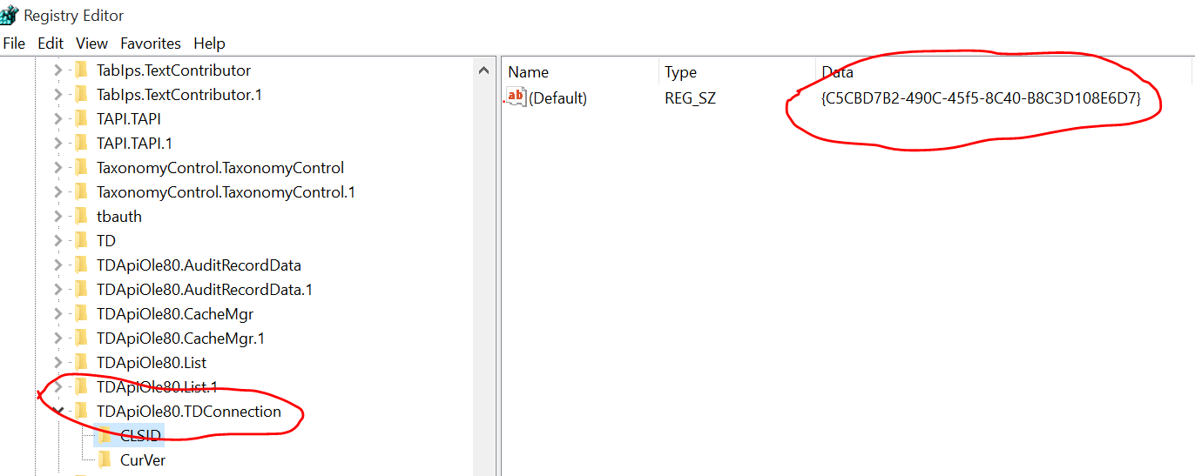
- Locate your COM object GUID under the HKey_Classes_Root\Wow6432Node\CLSID\[GUID]



- Once located add a new REG_SZ (string) Value. Name should be AppID and data should be the same COM object GUID you have just searched for

- Add a new key under HKey_Classes_Root\Wow6432Node\AppID\
The new key should be called the same as the com object GUID

- Under the new key you just added, add a new REG_SZ (string) Value, and call it DllSurrogate. Leave the value empty

- Create a new Key under HKey_Local_Machine\Software\Classes\AppID\
Again the new key should be called the same as the COM object’s GUID. No values are necessary to be added under this key.
That’s it, your COM Object should now be accessible from a 64bit environment and can be used like a regular COM Object.

Un-install QC Connectivity add-in

- Clear all IE cache data (ensure you don't have "Preserve Favorites website data" checked)
- Delete all files in "C:\Users\username\AppData\Local\HP" (or equivalent XP-style path)
- Access your QC URL with only "/qcbin" at the end
- Click "Add-Ins Page" link
- Click "HP ALM Client Registration" link
- This may take a while, including a warning in IE9 that the page has locked up.
- After this has installed, from the "Add-Ins Page", click "HP Quality Center Connectivity" link
- Once the connectivity add-in installation is finished, make the regedit changes as described as
above.

Change history

Version | Date | Author | Reviewed by | Approved by | Change history
V1.0 | 03-11-2017 | Priti Gaikwad |  |  | Created the document

